**CPU Scheduling Analysis Report and Simulation Programming**

***Due Date:5* /3/2024 midnight**

***Objective:*** The evaluation of 5 CPU scheduling algorithms in two different OS CPU scheduling structures

***OS Scheduling Stats Structures Diagram:***

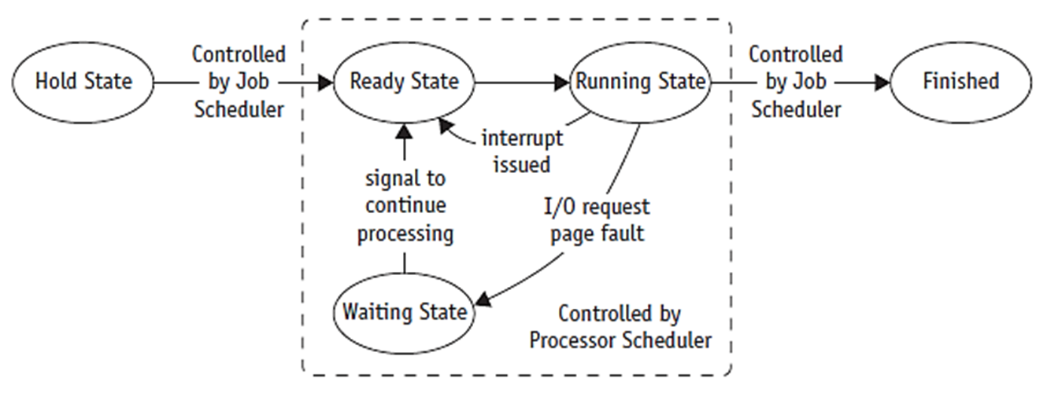

**One queue structure**:using one queue for ready states and waiting states.

**Two queues’ structures**: one queue for ready state and one queue for waiting states.

***Algorithms Description:***

1. **First-Come, First-Served Scheduling (FCFS):**

A process that requests the CPU first is allocated the CPU first.

1. **Shortest-Job-First Scheduling (SJF):**

This algorithm associates with each process the length of the latter’s next CPU burst. When the CPU is available, it is assigned to the process that has the smallest next CPU burst. If two processes have the same length next CPU burst, FCFS scheduling is used to break the tie.

1. **Shortest-Remaining-Time-First Scheduling (SRTF):**

This is preemptive SJF scheduling. It will preempt the currently running process to finish its CPU burst.

1. **Priority Scheduling:**

A priority is associated with each process, and the CPU is allocated to the process with the highest priority. Equal-priority processes are scheduled in FCFS order.

1. **Round-Robin Scheduling:**

It is similar to FCFS scheduling, but preemption is added to switch between processes. A small unit of time, called a time quantum, or time slice, is defined. Keep the ready queue as a FIFO queue of processes. New processes are added to the tail of the ready queue. The CPU scheduler picks the first process from the ready queue, sets a timer to interrupt after 1 time quantum, and dispatches the process.

***Instructions:***

1. Write a simulation program for CPU Scheduling Analysis
2. Based on the simulation program result to write the report for CPU Scheduling Analysis with IEEE format (see IEEE format guideline file).
3. Compare two different CPU scheduling structure: One Queue V.S. Two Queue.
4. Use data provide in Job Information table in Excel file (JobData.xlsx) for analysis.
5. Reports should use required format with graphical charts to support your analysis and it should have minimum 5 pages report.
6. Report should write in Microsoft Word with required format (IEEE format)
7. When you search online for information to use in your report, you need to have reference source information in your reference section at the end of report.
8. Name your report file as “CPU Scheduling Analysis” and add your name after file name.
9. Submission requirements: Visual Studio programming project folder, and report file (CPU Scheduling Analysis – Student’s Name)